EXPERIMENT 11

11.1.1//Sum of digits of a number
Ans: ALGORITHM
Step 1: Start
Step 2: Read the number num
Step 3: Initialize sum = 0
Step 4: Check if num > 0
Step 5: Find digit i = num % 10
Step 6: Add digit to sum → sum = sum + i
Step 7: Remove last digit → num = num // 10
Step 8: Go to Step 4
Step 9: Print sum
Step 10: Stop
FLOWCHART:
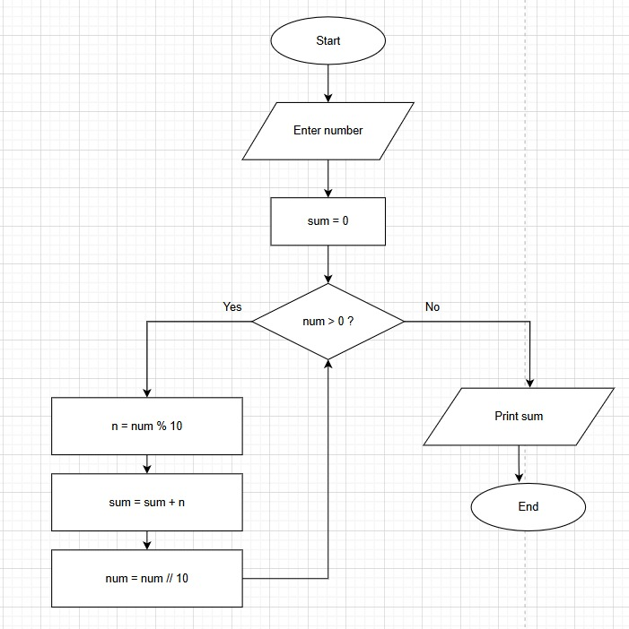

CODETANTRA:
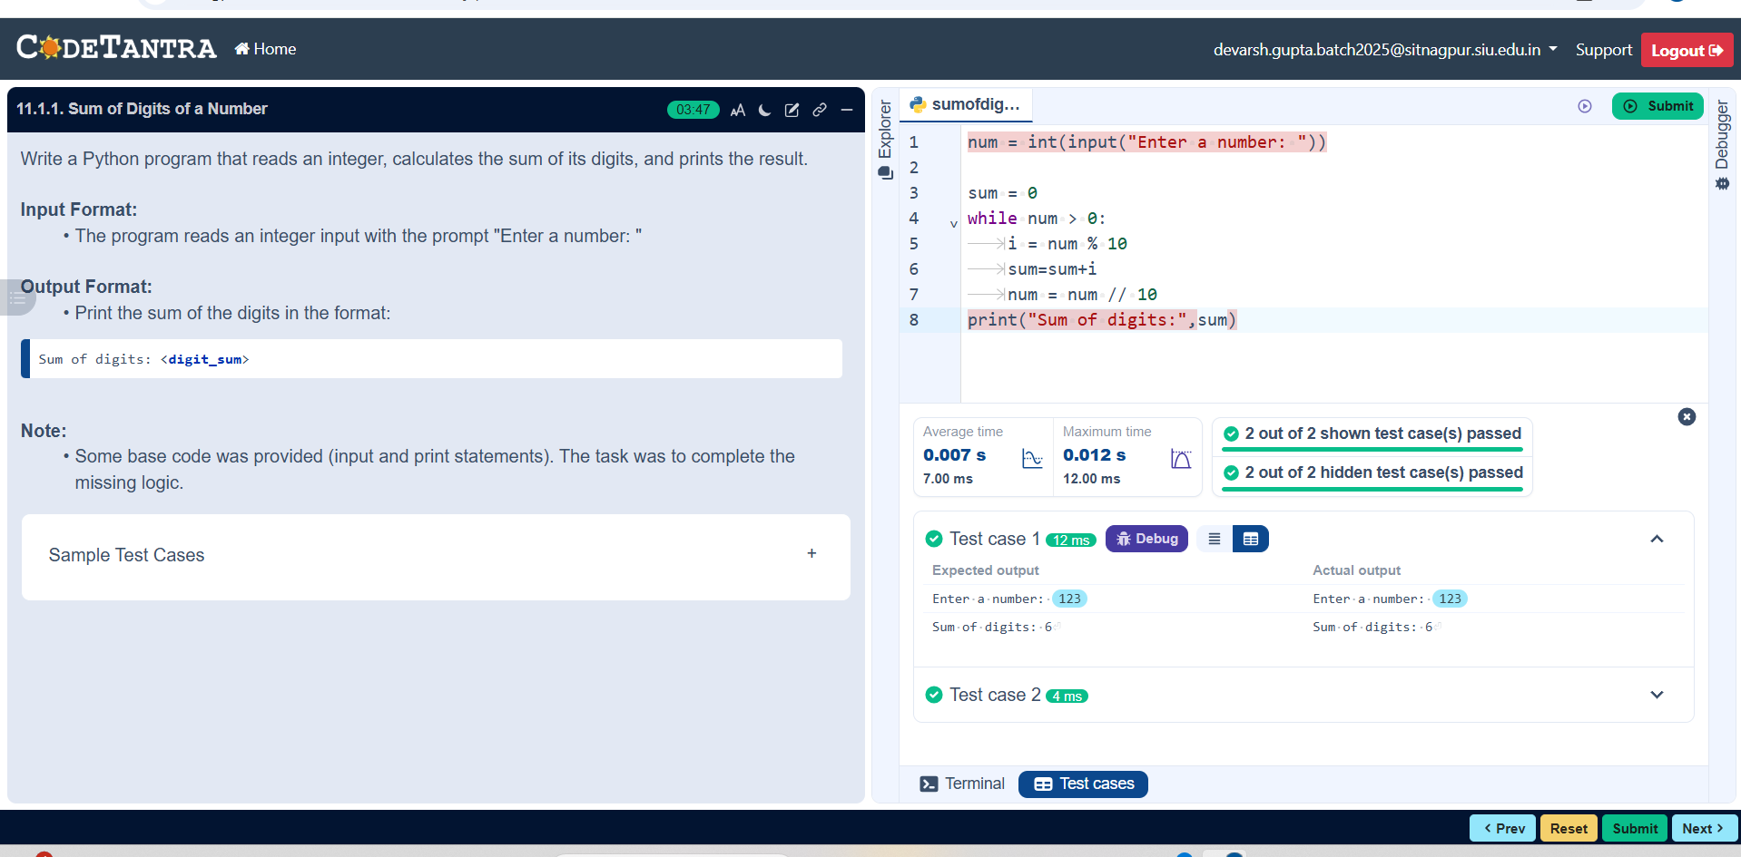

11.1.2//Sum of digits using recursion
Ans: ALGORITHM:
Step 1: Start
Step 2: Input number n
Step 3: Call function sum_of_digits_recursive(n)
Step 4: Check if n == 0
- If Yes, return 0
- If No, return (n % 10) + sum_of_digits_recursive(n // 10)
- Step 5: Store returned value in result
Step 6: Print result
Step 7: Stop
FLOWCHARt:
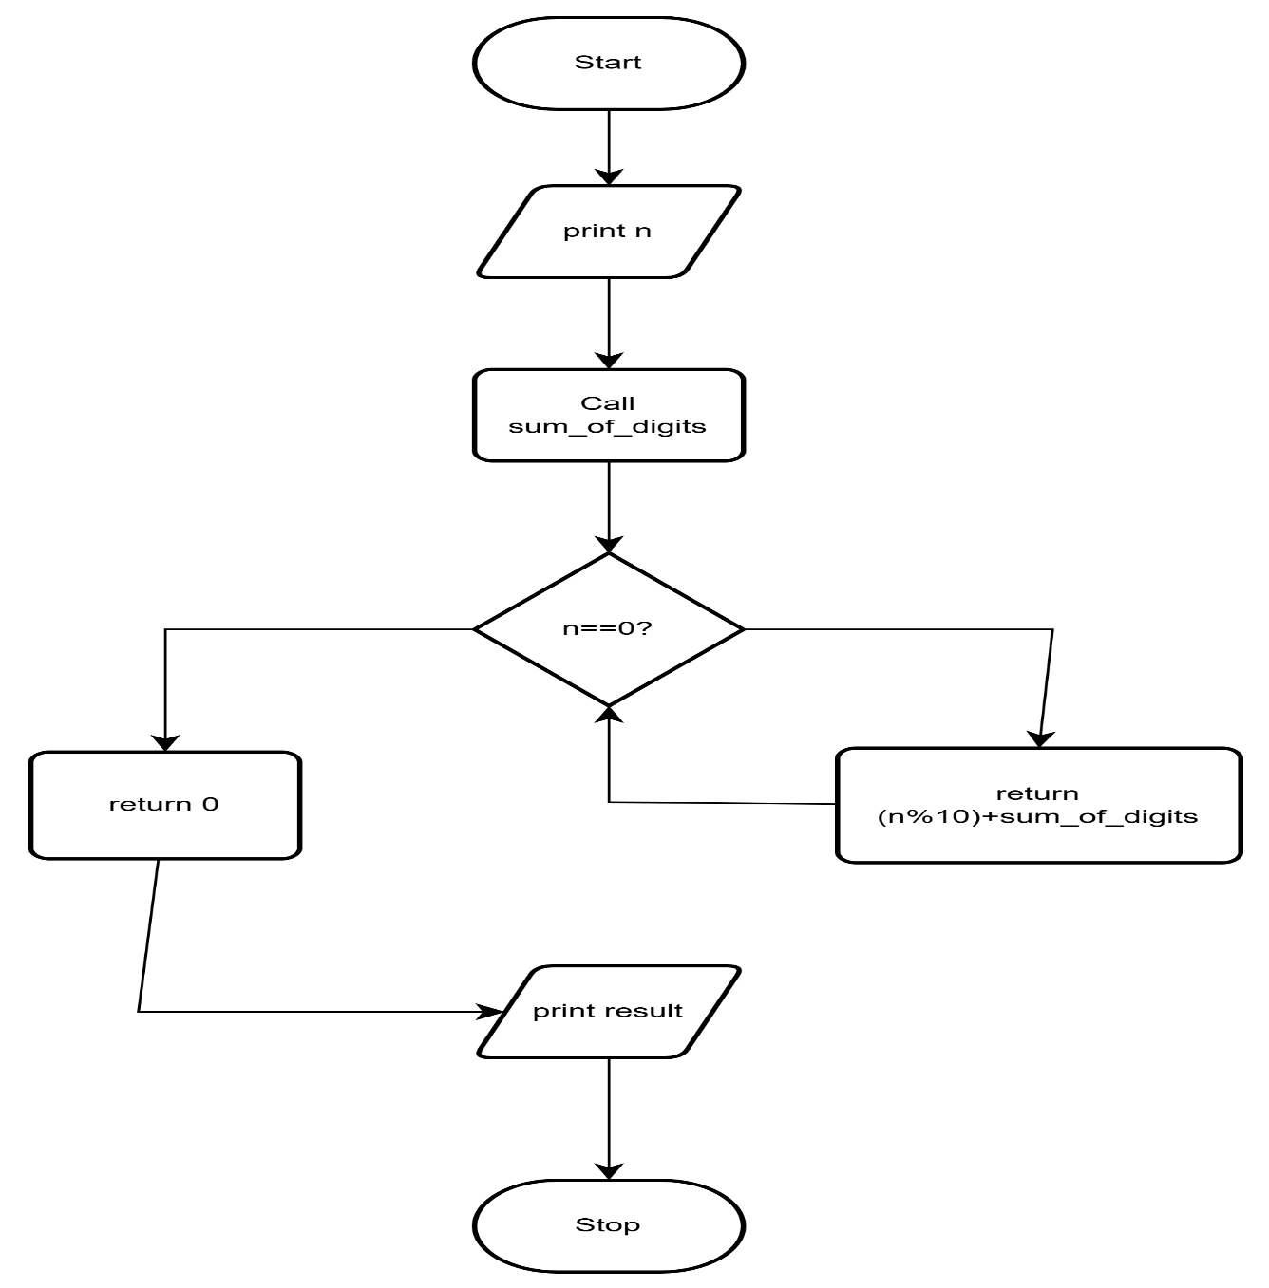

CODETANTRA:
